|  |  |  |
| --- | --- | --- |
| **THE PRACTICE**  Established in 1926 by Alistair Mead, the practice.  serves patients in Copnor and adjoining districts.  **THE PRESENT PARTNERS ARE:**  Dr Beth Hockley (F) BSc (Hons) MB ChB Leic (2009) DFSRH  Dr Zanoon Nazari MBChb, University of Aberdeen (2003) MRCGP, DFSRH  Dr Michaela Whyte-Venables MBBS MRCGP DFFP PGCME  **SALARIED GPS:**  Dr Thomas Wood (M)BM (Hons) Southampton (2011) MRCGP  Dr Robyn Elliott (F)BM Southampton (1999) MRCGP DRCOP, DFFP  Dr Sang Eun Lee (F) BSc (Hons) MBBS Hull & York (2011) MRCGP  Dr Aisha Quyyam MBBS Nigeria 2004 RGCP, UK 2017  Dr Maryam Brady BM Southampton MRCGP  **NURSE PRACTITIONERS:**  Sister Lisa Beard.  Practice Manager – Susan Miller  Business Manager – Tina Till  **NEW PATIENTS**  We register patients from postcodes PO2, PO3, PO4. Extended boundary PO5  Please come to the surgery to register between the hours of 10am – 4pm. New patient health checks should be booked with the healthcare support worker, and you are asked to bring a urine specimen with you when you attend your appointment.  The Practice Nurses Debbie Spicer and Debra Ward are available daily by appointment. We also have two Healthcare Support Workers.  **NAMED ACCOUNTABLE GP FOR ALL PATIENTS:** All Kirklands patients now have a named accountable GP.  The named accountable GP is responsible for the patients' overall care at the practice.  If you would like to know who that GP is please contact the surgery. You may express a preference which GP you would like.  **DISABLED ACCESS**.  The premises have access for disabled patients. Please let reception know if you are unable to use stairs and we can arrange for you to be seen in a downstairs treatment room. | **SURGERY OPENING TIMES**  Monday 8.30am – 6.30pm  Tuesday 8.30am – 6.30pm  Wednesday 8.30am – 6.30pm  Thursday 8.30am – 6.30pm  Friday 8.30am – 6.30pm  **ROUTINE APPOINTMENTS**  Monday to Friday- 8.30am- 12.00pm -2.00pm-5.30pm  Emergency appointments are available every morning.  Please telephone between 8.30am-11.00am  **EMERGENCY TELEPHONE CONTACT**  Between the hours of 8am – 6.30 pm tel: 023 92663368  If you need to be seen out of hours, please first call 111 Only use Accident and Emergency in the case of a genuine medical emergency  **EXTENDED HOURS**  Wednesday 6.30pm – 7.00pm  Tuesday 7.15am – 8.00am  **HOME VISITS**  Patients are encouraged to visit the surgery wherever possible. If you feel a visit may be required please telephone the surgery before 11.00am on 023 92 663368  **LOCAL WALK-IN CENTRES**  St Mary’s NHS Treatment Centre  Milton Road, Portsmouth. PO3 6DW  0333 200 1822  **SPECIAL APPOINTMENTS**  Minor surgical procedures are carried out by special arrangement. Appointments for blood pressure care, diabetic management, asthma, well-women or  well-men advice is all available in normal surgery times by all  the doctors and practice nurses.  **REPEAT PRESCRIPTONS**: You may request repeat prescriptions, preferably with their computer printout in writing, in person or in writing. For patients` safety we DO NOT ACCEPT TELEPHONE PRESCRIPTION REQUESTS. The prescription will be ready for collection after two working days or can be posted if a SAE is included in the request. Friday requests will not be ready until Tuesday afternoon. | **YOUR HEALTH**  Blood Pressure – we would suggest that you have your BP checked at least once every three years, this can be booked with any of our HCA’s.  **Cervical smears** – we recommend that all women have a cervical smear following national guidelines.  **Childhood Immunisations** – the doctor, practice nurse can advise you on appropriate immunisation prior to your appointment if you have any concerns.  **Travel vaccinations** – the practice nurses offer a comprehensive service for travel advice and vaccination by appointment, travel forms must be completed before your appointment.  **CARERS SUPPORT** Please let us know if you are looking after an elderly, sick or disabled person and need help obtaining an assessment or advice on claiming benefits.  **ONLINE PATIENT SERVICES** We offer patients access to online appointment booking and repeat prescription ordering via the national Patient Access website. Patients can also view selected information on their medical records including medications, allergies & immunisations. Please go to our website [www.kirklandsurgery.co.uk](http://www.kirklandsurgery.co.uk) to register for an online account.  **ACCESS TO MEDICAL RECORDS** All patients are entitled to have access to their medical records. If you wish to see your notes, please ask for a form at reception. All information about you is strictly confidential. Information may be shared with other healthcare professionals on a ‘need to know’ basis regarding your continuing care. We will always seek our written consent before releasing information to third parties.  **GENERAL DATA PROTECTION REGULATIONS**  We are compliant with GDPR 2018. Our Privacy Notices are available in the waiting room and online at www.kirklandssurgery.co.uk.  Sdrive:practiceleaflet2020 |

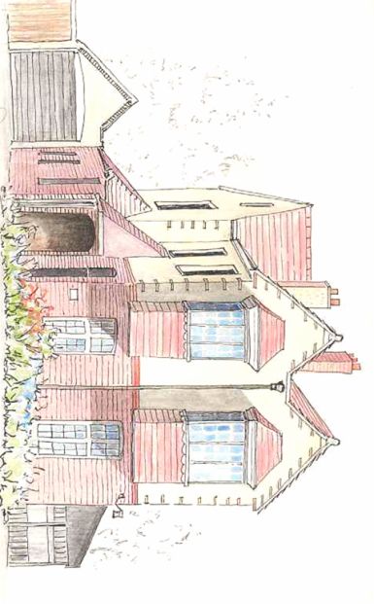

***Kirklands Surgery Practice Leaflet***

**SITUATION AND CAR PARKING**

We regret that there is insufficient space to be able to offer PATIENTS car parking facilities on the premises. However, there is ample space in the driveway for private cars or taxis to `**drop off’** and `**pick up’** patients who have difficulty walking.

The best car parking possibilities are in Powerscourt Road.

**WE ARE HERE**



**Patient Participation Group:**

**If you are interested in joining the patient group, please enquire at reception desk.**

**ZERO TOLERANCE** Our staff are here to help you and we aim to treat all our patients courteously at all times and expect our patients to treat our staff in a similarly respectful way. We take seriously any threatening, abusive or violent behaviour against any of our staff or patients.

**COMPLAINTS & SUGGESTIONS** We are very interested in your views of the service we are providing. If there is something that we are doing well, and you would like to tell us about it – or something that you think we could be doing better – speak to a receptionist or ask to see the Practice Manager. If you would like to make a formal complaint, you can do this in writing or by speaking with the Practice Manager – in person or by telephone.

NHS England operates a customer contact centre regarding issues relating to GP practices, the contact details are – tel 0300 311 22 33, e-mail england.contactus@nhs.uk

**YOU CAN HELP US BY:**

Being on time for your appointment

Letting us know if you need to cancel an appointment.

Calling for a home visit or urgent appointment before 10am Phoning for results of tests after 2pm

**ITEMS FOR WHICH THERE IS A CHARGE** All charges are in line with the recommended BMA rates. For details, please ask at reception.

**USEFUL TELEPHONE NUMBERS**

Social Services….Children & families…... 9283 9111

Older persons………… 9289 3800

Alcoholics Anonymous…………………... 0800 917 7650

Carers Helpline…………………………… 0845 722 1122

Childline………………………………….. 0800 1111

Drug & Alcohol Advice………………….. 9229 4573

Samaritans………………………………... 9269 1313

Help In Bereavement…………………….. 9266 8884

Police……………………………………… 101

NHS Direct……………………….. 111

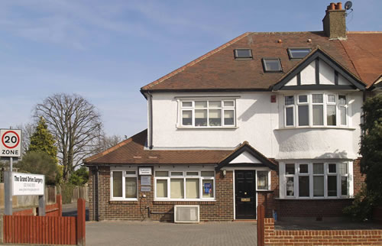-

***The Partners***

***Dr E Hockley***

***Dr Z Nazari***

***Dr M Whyte-Venables***

**111 Copnor Road,**

**Portsmouth,**

**PO3 5AF**

**Telephone 023 92 663368**

**www.kirklandssurgery.co.uk**